PLANNING COMMITTEE REPORT

Application Number | 2022/0065/COU
Date Received | 28th January 2022
Date of Expiry | 18th April 2022 (EOT agreed 08.06.2022)
Case Officer | Tom Cannon
Ward | Oakham
Ward Councillor | Councillor Robert Elliman
Committee Date | 4th July 2022

Site Address: | 192 Nottingham Road, Mansfield, Nottinghamshire NG18 4AF
Proposal: | CHANGE OF USE FROM CAR RENTAL SITE TO DRIVE THROUGH HAND CAR WASH, INCLUDING SPLASH SCREENS AND ASSOCIATED DEVELOPMENT (RETROSPECTIVE)
Applicant: | Starfish Mansfield Limited

RECOMMENDATION – GRANT PLANNING PERMISSION WITH CONDITIONS

Update report

Members will recall that the committee resolved to grant permission at the June meeting for the retrospective change of use of this former car rental site to a car wash with associated development. A copy of the committee report is appended below (Appendix A).

Since the application was last before members, the application site has been reduced in size, omitting an area along the southern boundary of the site. This area, which now falls outside the car wash application site is included in the red line boundary of the application site for an MOT centre which is also currently before committee at the adjoining premises (Ref: 2022/0102/COU). Two tandem staff parking spaces for the MOT centre would be included in this area. As a consequence, two staff parking spaces for the car wash would be re-ordered in a tandem formation on the southernmost part of the amended application site for the car wash. This differs from the layout which committee previously resolved to grant showing two staff parking spaces for the car wash shown ‘side by side’.

Officers consider that the revisions to the layout and allocation of the parking spaces combined with the reduction in the size of the application site would ensure that staff parking for both the car wash and MOT centre can co-exist effectively, without having an adverse impact on highway safety or increase the potential for on-street parking in the locality. A minor revision to condition 3, referring to how the management of the staff parking spaces would be managed, should also provide further reassurance to local residents, who have raised concerns in relation to the cumulative impact of the two applications on highway safety/parking. The wording of condition 3 in the 6th June committee report (Appendix A) would be amended as follows:

Condition 3:
‘Within 2 months of the date of this decision a Site Management Plan shall be submitted to and approved in writing by the local planning authority, setting how the car wash will be managed to safeguard vehicular and pedestrian safety in Nottingham Road. The Site Management Plan shall include:
- How customer and staff vehicles arriving at the site will be managed to prevent the build up of traffic on Nottingham Road;
- The marking out of customer and staff parking spaces and their retention in perpetuity for the parking of customers/staff; and
- How jet washing will be managed to prevent spray adversely impacting on pedestrian users of the adjacent footway on Nottingham Road.

The car wash shall then operate in accordance with the approved Site Management Plan for the lifetime of the development.’

Local residents and the highway authority have been re-consulted on the revisions, with their comments due by 7th July 2022.

RECOMMENDATION

Members are therefore recommended to GRANT PLANNING PERMISSION WITH CONDITIONS and delegate to the HEAD OF PLANNING & REGENERATION SERVICES to issue the decision at the end of the re-consultation period providing that no new material planning considerations are raised, subject to the conditions contained in the 6th June committee report (Appendix A), and the following updated conditions:

(1)
Condition: This permission shall be read in accordance with the Approved Plans listed below.

(1)
Reason: To define the permission, and for the avoidance of doubt

(2)
Condition: Within 2 months of the date of this decision a Site Management Plan shall be submitted to and approved in writing by the local planning authority, setting how the car wash will be managed to safeguard vehicular and pedestrian safety in Nottingham Road. The Site Management Plan shall include:
- How customer and staff vehicles arriving at the site will be managed to prevent the build up of traffic on Nottingham Road;
- The marking out of customer and staff parking spaces and their retention in perpetuity for the parking of customers/staff; and
- How jet washing will be managed to prevent spray adversely impacting on pedestrian users of the adjacent footway on Nottingham Road.

The car wash shall then operate in accordance with the approved Site Management Plan for the lifetime of the development.

(2)
Reason: In the interests of highway safety and to accord with Policy IN9 of the Mansfield District Local Plan.

(3)
Condition: The use hereby permitted shall only be open to the public during the following hours: 08.00 – 18.00 seven days a week.

(3)
Reason: In the interests of residential amenity and to accord with Policy P7 of the Mansfield District Local Plan.

Notes to Applicant

(1)
Positive and Pro-active Statement
The application as submitted was acceptable to the Local Planning Authority who has therefore worked in a positive and proactive manner with the applicant in line with the NPPF.

INFORMATIVE

This application does not grant or imply consent for the signage which has been installed/erected at the site which will require the benefit of separate advertisement consent. An application for retrospective advertisement consent should therefore be made to retain this signage. The Council Enforcement Officer has been made aware of this situation and you could therefore be subject to a further enforcement investigation if an application is not submitted for advertisement consent within 4 weeks of the date of this decision.

Approved Plans
Description | Reference No | Version | Date Received
Proposed Site Plan | 21933-0310 | Rev 7 | 22.06.2022
Site Location Plan  Existing and proposed Elevations (Excluding signage)  Further Proposed works  Drainage Plan | 21933-0201  21933-0210 | Rev 1 | 22.06.2022  28.01.2022  28.03.2022  28.03.2022

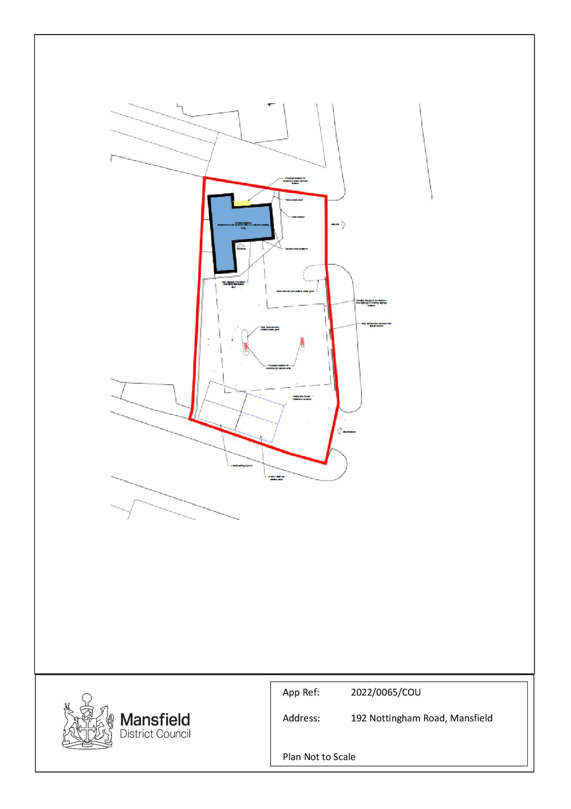

Appendix A

Committee report dated 6th June 2022.

PLANNING COMMITTEE REPORT

Application Number | 2022/0065/COU
Date Received | 28th January 2022
Date of Expiry | 18th April 2022 (EOT agreed 08.06.2022)
Case Officer | Tom Cannon
Ward | Oakham
Ward Councillor | Councillor Robert Elliman
Committee Date | 6th June 2022

Site Address: | 192 Nottingham Road, Mansfield, Nottinghamshire NG18 4AF
Proposal: | CHANGE OF USE FROM CAR RENTAL SITE TO DRIVE THROUGH HAND CAR WASH, INCLUDING SPLASH SCREENS AND ASSOCIATED DEVELOPMENT (RETROSPECTIVE)
Applicant: | Starfish Mansfield Limited

RECOMMENDATION – GRANT PLANNING PERMISSION

The application has been referred to the Planning Committee due to the number of objections raised from interested parties.

Summary of the Proposal and Site

The application site lies on the western side of Nottingham Road, adjacent to the junction with Stanley Street. It comprises of a former filling station, which has latterly operated as a car rental centre. Earlier this year, the site started to operate as a hand car wash, with external alterations made to the site including, the erection of splash screens along the Nottingham Road frontage, new company and directional signage erected to the canopy and single storey building on the site. This application therefore seeks retrospective planning permission for the use of the site as a hand car wash and retention of the associated physical alterations (i.e. splash screens, jet wash and vacuum housing and fencing). The signage which has been erected may require the benefit of advertisement consent and does not therefore form part of this application for planning permission. The car wash opens between the following hours: 08.00-18.00 daily.

It is understood that no excavation works have taken place to the hard surfaced yard other than the removal of a small raised kerb adjacent the site exit. The existing entry and exit points off Nottingham Road have also been retained for the car wash. Two parking spaces in the south-west corner of the site are also shown for staff parking.

Relevant Planning History

(Adjacent site)
2022/0102/COU

CHANGE OF USE OF VEHICLE RENTAL UNIT TO MOT SERVICE STATION AND VEHICLE REPAIRS
2 Stanley Road, Mansfield, Nottinghamshire
Pending consideration.

Relevant Planning Policies/Guidance

Adopted Mansfield District Local Plan 2020
S1 - Presumption in favour of sustainable development
S2 - The Spatial Strategy
S4 – Urban regeneration
P1 - Achieving high quality design
P2 – Safe, healthy and attractive development
P3 – Connected developments
P5 – Climate change and new development
P7 – Amenity
IN9 - Impact of development on the transport network
IN10 – Car and cycle parking
CC2 – Flood risk
CC3 – Sustainable drainage systems

National Planning Policy Framework:

Chapter 2 – Achieving sustainable development
Chapter 4 – Decision making
Chapter 9 – Promoting sustainable transport
Chapter 11 – Making efficient use of land
Chapter 12 – Achieving well designed places
Chapter 14 – Meeting the challenge of climate change, flooding and costal change

Statutory, Internal and Other Consultees

Notts County Council Highways

(13.04.2022) – This is an application from car rental to a drive through car wash. The existing access arrangements will remain with an in/out system and the canopy and building will also remain. It is noted that there will be two spaces provided for the adjacent MOT station. There are no reported accidents on the junction of Nottingham Road/Stanley Road and the change of use will not be an unacceptable intensification of the site therefore we would not wish to raise objection to the proposal.

Notts County Council Flood Risk Management Team

(29.04.2022) – No objections or comments to make.

MDC Environmental Health

(06.05.2022) – No objections, subject to conditions restricting the hours the premises is open to the public to between 08.00-18.00.

The applicant should be aware that the site, as a former petrol station, is classed as ‘land which may be contaminated’. Although the fuel dispensers have been removed, the tanks and associated pipework are still present underground, and if works are proposed that will include excavation of the forecourt, the advice of the Environmental Health section should be sought prior to the works taking place.

Neighbour Consultations/Publicity

Letter Type | Date Sent
Standard Neighbour Letter | 10.02.2022 & 07.03.2022

Site Notice Posted – 10.02.2022

Representations

A total of 9 representations received from 7 neighbouring residents, 8 objecting to and 1 in support of the application. These comments are summarised below:

Objecting:

- Car wash already opened, why are they allowed to do this without gaining permission first?
- Use will lead to congestion on Nottingham Road from vehicles waiting to access the site due to its limited size;
- Insufficient staff parking shown;
- Increase on street car parking in the area in an area which has limited parking provision;
- Insufficient staff parking shown;
- It is unclear how the car wash and proposed MOT station next door will co-exist;
- Noise pollution from jet washers/vacuum;
- How will polluted water/hazardous cleaning products be disposed of?
- Site contaminated from its former use as a filling station;
- Spray from pressure washers affect pedestrians on the adjacent footway;
- External alterations to the site visually intrusive.

Support
- Ideal location for a car wash and the set up looks very professional

Assessment

The key issues to be assessed in the determination of this planning application are:

- The principle of the development;
- The effect of the access and parking arrangements on highway safety in Nottingham Road;
- The effect the development has on the living conditions of nearby residents;
- The effect of the car wash on the character and appearance of the area;
- Whether adequate facilities have been provided for the disposal of surface water associated with the development; and
- Whether the use development poses pollution/contamination risks given the nature of the use/former use on the site.

1. The principle of development

Policy S2 of the Mansfield District Local Plan (MDLP) seeks to focus new employment and community facilities within the Mansfield urban area on previously developed sites or derelict/surplus land. The car wash has brought back into use a redundant former filling station/car rental site within the Mansfield urban area. It would also provide 4 full-time equivalent jobs and therefore broadly accords with the overall aims of Policy S2 of the MDLP.

2. Highway safety

The site lies on Nottingham Road, immediately adjacent to its junction with Stanley Road, a predominately residential street, with a vehicle repair centre directly to the rear. It is understood that the existing ‘in-out’ access from Nottingham Road served its former uses as a both a filling station and car rental site, with the car wash retaining these historic access arrangements.

It is acknowledged that Nottingham Road is a busy route, with high traffic flows both into and out of the town centre. Local residents have also raised concerns that the use if continued would cause congestion in this area. However, the number and nature of vehicular movements associated with the use of the site as a car wash are broadly comparable to its longstanding historic use as a filling station. The Highway Authority is also satisfied that the car wash has not resulted in an unacceptable intensification in the use of the site and is satisfied that the access arrangements do not have an adverse impact on highway safety in Nottingham Road.

To ensure that vehicles attempting to access the car wash do not wait on the highway and cause an obstruction to road users, a condition is recommended requiring the submission of a site management plan detailing how vehicles waiting to use the facility will be managed.

Concerns regarding the impact on existing on-site parking in adjoining streets are noted, particularly Stanley Road, although this has existing parking restrictions (maximum stay 2hrs and no returns within 1 hr and resident parking permit spaces). However, the afore-mentioned management plan should ensure that customers using the car wash do not need to park on adjoining streets and therefore impact on the demand for parking on nearby roads.

The premises employs 4 full-time members of staff members, with 2 parking spaces provided for their use. As the majority these employees live locally and walk to work, this level of provision is considered appropriate. Local residents have also questioned how the car wash will co-exist with the current planning application for an MOT station at the adjoining premises. Although the application originally showed 2 MOT bays on the car wash site to serve the proposed MOT service station at the adjoining premises, these spaces have now been omitted from this application.

Concerns have also been raised regarding spray from the car wash affecting pedestrian users of Nottingham Road. Whilst it is acknowledged that a small amount of spray may encroach over the adjacent footway, the splash screens which have been installed are approximately 2m high which, it is understood is recommended as the industry standard. The footway on Nottingham Road is also quite wide, meaning that pedestrians can pass without having to walk immediately adjacent to the screens. That said, details of how spray from the jet washers could be limited to ensure that it does not cause a nuisance to pedestrian users of the adjacent footway can also form part of the proposed site management plan condition.

Overall it is considered that, subject to the afore-mentioned conditions, safe and suitable access to the site can be achieved and the proposal does not have a significant impact on highway safety. In this respect, the proposal accords with Policies IN9 and IN10 of the MDLP which, amongst other things, seek to ensure that development does not endanger highway safety and provides appropriate levels of parking provision for vehicles.

3. Living conditions

There are existing residential properties in Stanley Road and Nottingham Road to the south, north-west and east of the site. The level of noise and disturbance to adjacent residential properties has to be considered within the context of the lawful use of the site as a petrol filling station. The volumes and frequency of traffic entering and leaving the site in association with the car wash are considered broadly comparable with a petrol filling station.

Therefore, the main consideration with the use of the site as a car wash, is whether the noise generated by the use of pressure washers, vacuums etc, would adversely impact on the living conditions of the occupiers of nearby residential properties.

The applicant has submitted a detailed layout plan of the car wash showing the location of the jet washers and vacuums. This equipment will be operated under the existing canopy/adjacent to the existing office building on the site, away from residential properties. Therefore, due to the separation distance involved, it is considered that the noise associated with the operation of this equipment does not cause undue noise or disturbance to those properties. This assessment is corroborated by the lack of objection to the proposals for the Council’s Environmental Health Officer (EHO). Moreover, there do appear to have been any complaints made to the EHO regarding noise since the car wash has been operational.

For the reasons set out above, subject to a condition restricting the hours of use of the car wash to those specified in the application forms (08.00-18.00hrs) the car wash does not have an adverse impact on residential amenity. It therefore accords with Policy P7 of the MDLP which require that development is designed and constructed to avoid and minimise impacts on the amenity of both existing and future users.

4. Character and appearance

The site occupies a prominent position fronting onto Nottingham Road. Various alterations have been made to the site including, new Perspex splash screens along the site frontage, painting of the external walls, canopy and office building in blue and white, the installation of vacuums and jet washer units, and alterations to the internal kerb line within the site. These alterations are relatively modest and have enhanced the appearance of what was a redundant car rental lot. Various signage has also been added across the site which may require separate advertisement consent. An informative note is to be added, advising the applicant that this planning permission does not grant or imply consent for the signage which has been installed, with an application for advertisement consent required to retain these elements.

Overall, officers are satisfied that the external works undertaken to provide the car wash preserve the character and appearance of the area. As such, the development accords with Policy P2 of the MDLP which, amongst other things, seeks to ensure that development respects existing patterns of development which contribute to the character of the area.

5. Surface water disposal

The site lies in flood zone 1, land with a low flood risk. The applicant has submitted a drainage report/layout plan which shows how existing surface water from the car wash is disposed of. It is understood that the channel drains were cleaned out and repaired prior to the use commencing.

In detail, surface water from the car wash is dispersed via a channel drain and three interceptor pits before entering the main drain on Nottingham Road. The interceptor pits are designed to stop contaminants from the car wash creating a pollution hazard before they enter the main drainage system.

The County Flood Risk Management Team raise no objections to the method of surface water disposal. As such, the surface water arrangements for the car wash ensure that there is no risk of flooding on the site or surrounding land, and any contaminants from the development do not pollute the main drainage system. In this respect, the proposal would accord with Policies CC2 and NE3 which seek to ensure that development does not increase flood risk or water pollution.

6. Contamination risks

The site has previously been used as a filling station and therefore classed as land which may be contaminated. The Environmental Health Officer understands that the fuel dispensers have been removed, although the tanks and associated pipework are still likely to be present. Therefore, any excavation of the forecourt could impact on these underground tanks/pipework.

The applicant has confirmed that the works undertaken to provide the car wash have not involved any excavations of the forecourt, with the only ground works involving the removal of two kerbs adjacent to the site exit on Nottingham Road. This has comprised of patching up of the surface without any extensive excavation work. Therefore, the development has not increased contamination risks associated with its former use as a filling station.

As such, it would accord with Policy NE3 of the MDLP which, amongst other things, seeks to ensure that development proposals should ensure that there would be no risk from sites which may potentially be contaminated.

Other matters

Local residents have raised concerns as to why the applicant has been allowed to carry out the works before gaining planning permission and the potential impact of the development on property values. In respect of the former, as soon as the Council Enforcement Officer became aware of the works taking place, an application for retrospective planning permission was requested. This application seeks to regularise the unauthorised works.

Conclusion

The car wash has brought back into use a redundant former filling station/car rental site within the Mansfield urban area and provides 4 full-time equivalent jobs. These economic benefits clearly weigh in favour of the scheme and accord with the objectives of Policy S2 of the MDLP which seeks to focus new employment and community facilities within the Mansfield urban area on previously developed sites or derelict/surplus land. It also does not have an adverse impact on highway safety, the living conditions of nearby residents or the character and appearance of the area. Nor would it increase the risk of flooding or contamination on the site or surrounding land. As such, the scheme accords with Policies S2, IN9, IN10, P2, P7, CC2 and NE3 of the MDLP. As such, it is recommended that planning permission be granted, subject to conditions.

RECOMMENDATION

Grant Planning permission, subject to the following conditions:

(1)
Condition: The development hereby permitted shall be begun before the expiration of three years from the date of this permission.

(1)
Reason: In accordance with Section 91(1) of the Town and Country Planning Act 1990, as amended by S51(1) of the Planning and Compulsory Purchase Act 2004.

(2)
Condition: This permission shall be read in accordance with the Approved Plans listed below.

(2)
Reason: To define the permission, and for the avoidance of doubt

(3)
Condition: Within 2 months of the date of this decision a Site Management Plan shall be submitted to and approved in writing by the local planning authority, setting how the car wash will be managed to safeguard vehicular and pedestrian safety in Nottingham Road. The Site Management Plan shall include:

How customer vehicles arriving at the site will be managed to prevent the build-up of traffic on Nottingham Road; and

How jet washing will be managed to prevent spray adversely impacting on pedestrian users of the adjacent footway on Nottingham Road.

The car wash shall then operate in accordance with the approved Site Management Plan for the lifetime of the development.

(3)
Reason: In the interests of highway safety and to accord with Policy IN9 of the Mansfield District Local Plan.

(4)
Condition: The use hereby permitted shall only be open to the public during the following hours: 08.00 – 18.00 seven days a week.

(4)
Reason: In the interests of residential amenity and to accord with Policy P7 of the Mansfield District Local Plan.

Notes to Applicant

Positive and Pro-active Statement

The application as submitted was acceptable to the Local Planning Authority who has therefore worked in a positive and proactive manner with the applicant in line with the NPPF.

INFORMATIVE

This application does not grant or imply consent for the signage which has been installed/erected at the site which will require the benefit of separate advertisement consent. An application for retrospective advertisement consent should therefore be made to retain this signage. The Council Enforcement Officer has been made aware of this situation and you could therefore be subject to a further enforcement investigation if an application is not submitted for advertisement consent within 4 weeks of the date of this decision.

Approved Plans

Description | Reference No. | Version | Date Received
Proposed Site Plan | 21933-0310 | Rev 5 | 18/05/2022
Site Location Plan | 21933-0201 |  | 28/01/2022
Existing and proposed elevations  (excluding signage) | 21933-0210 |  | 28/01/2022
Further proposed works |  |  | 28/03/2022
Drainage Plan |  |  | 28/03/2022

Human Rights Act
Regard has been given to the following articles where applicable in consideration of this application. The Council’s Solicitor & Monitoring Officer is happy to advise on the application of the Human Rights Act should any particular issue arise.

Articles 6, 7, 8, 9, 10, 11, 14 and 18 Article 1 1st Protocol

